**Software Upgrade and Patch Management**

Student Version



Huawei Technologies Co., Ltd.

|  |
| --- |
| **Copyright © Huawei Technologies Co., Ltd. 2020. All rights reserved.**  No part of this document may be reproduced or transmitted in any form or by any means without prior written consent of Huawei Technologies Co., Ltd.  **Trademarks and Permissions**  HW_POS_RBG_Vertical-150ppi.png and other Huawei trademarks are trademarks of Huawei Technologies Co., Ltd.  All other trademarks and trade names mentioned in this document are the property of their respective holders.  **Notice**  The purchased products, services and features are stipulated by the contract made between Huawei and the customer. All or part of the products, services and features described in this document may not be within the purchase scope or the usage scope. Unless otherwise specified in the contract, all statements, information, and recommendations in this document are provided "AS IS" without warranties, guarantees or representations of any kind, either express or implied.  The information in this document is subject to change without notice. Every effort has been made in the preparation of this document to ensure accuracy of the contents, but all statements, information, and recommendations in this document do not constitute a warranty of any kind, express or implied. |

|  |  |
| --- | --- |
| Huawei Technologies Co., Ltd. | |
| Address: | Huawei Industrial Base  Bantian, Longgang  Shenzhen 518129  People's Republic of China |
| Website: | <https://e.huawei.com/> |

**Huawei Certification System**

Huawei Certification follows the "platform + ecosystem" development strategy, which is a new collaborative architecture of ICT infrastructure based on "Cloud-Pipe-Terminal". Huawei has set up a complete certification system consisting of three categories: ICT infrastructure certification, platform and service certification, and ICT vertical certification. It is the only certification system that covers all ICT technical fields in the industry. Huawei offers three levels of certification: Huawei Certified ICT Associate (HCIA), Huawei Certified ICT Professional (HCIP), and Huawei Certified ICT Expert (HCIE). Huawei Certification covers all ICT fields and adapts to the industry trend of ICT convergence. With its leading talent development system and certification standards, it is committed to fostering new ICT talent in the digital era, and building a sound ICT talent ecosystem.

Huawei Certified ICT Associate-Datacom (HCIA-Datacom) is designed for Huawei's frontline engineers and anyone who want to understand Huawei's datacom products and technologies. The HCIA-Datacom certification covers routing and switching principles, basic WLAN principles, network security basics, network management and O&M basics, SDN and programmability and automation basics.

The Huawei certification system introduces the industry, fosters innovation, and imparts cutting-edge datacom knowledge.

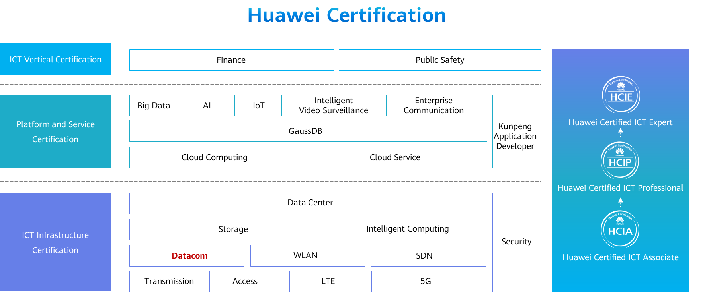

# Software Upgrade and Patch Management

## Objectives

Upon completion of this task, you will be able to:

Set up an FTP server.

Perform command-line interface (CLI)-based software upgrade.

Perform CLI-based patch management.

Perform web-based software upgrade and patch management.

## Background

As a network administrator of a company, you need to check the system software versions and patch information of devices to ensure that the devices support various functions. When Huawei releases the updated system software versions and patches, you need to upgrade the software and patches of the devices.

## Topology

Lab topology

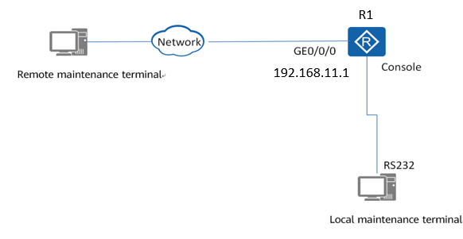

This exercise aims to help you perform system software upgrade and patch management. This exercise uses the AR2220 as an example. The operations on other devices are similar. For details, refer to this document and related Huawei product manuals.

## Implementation

### Roadmap

1. Verify the integrity of the system software and patch.
2. Check whether the current device meets the pre-upgrade requirements.
3. Perform CLI-based software upgrade and patch management.
4. Perform web-based software upgrade and patch management.

### Procedure

Prepare the target system software and patch.

Run the **display device** command to check the product name. If you have any questions, contact technical support.

Run the **display startup** and **display version** commands to check the running software and patch versions of the device.

Log in to https://support.huawei.com/enterprise and download the target system software and patch. Both the digital signatures for the system software and patch must be downloaded.

Click the following link to download the digital signature verification tool PGP Verify: https://support.huawei.com/enterprise/en/tool/software-digital-signature-openpgp-validation-tool-TL1000000054

Verify the integrity of the system software and patch.

#Open PGP Verify and select the public key file attached to the software, as shown in Figure 1-2.

Selecting the public file in PGP Verify

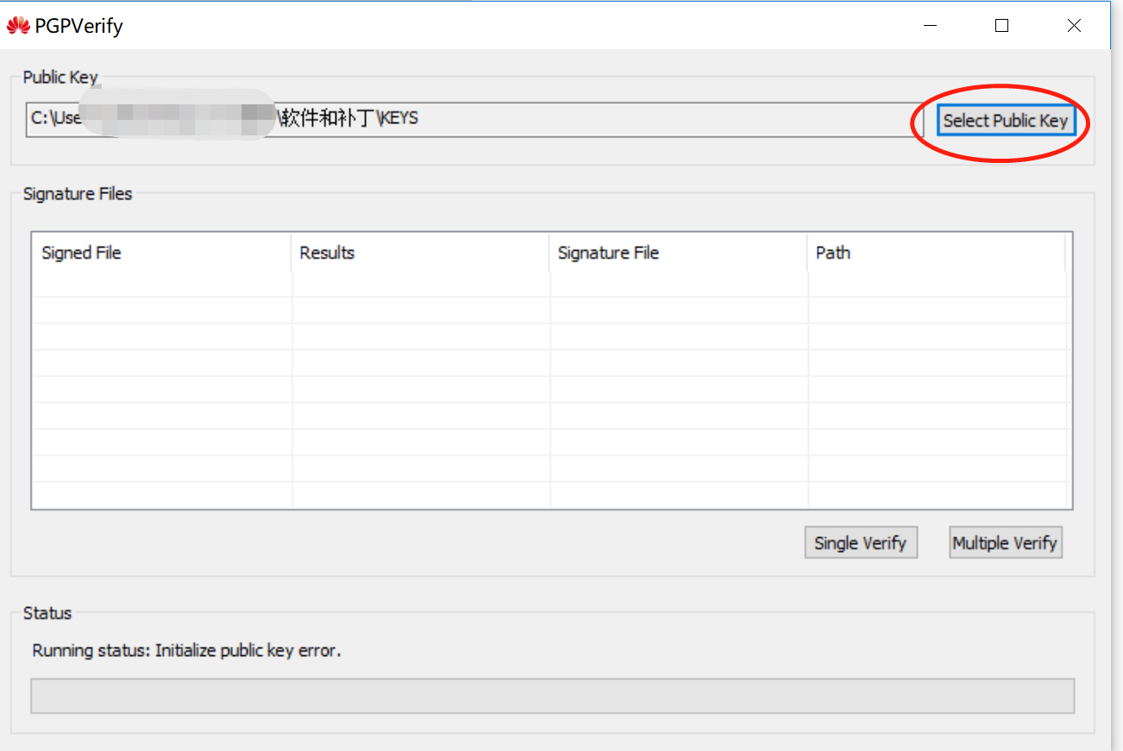

#Verify the integrity of the system software. Click **Single Verify** and select the digital signature file for the system software.

Verifying the integrity of the system software

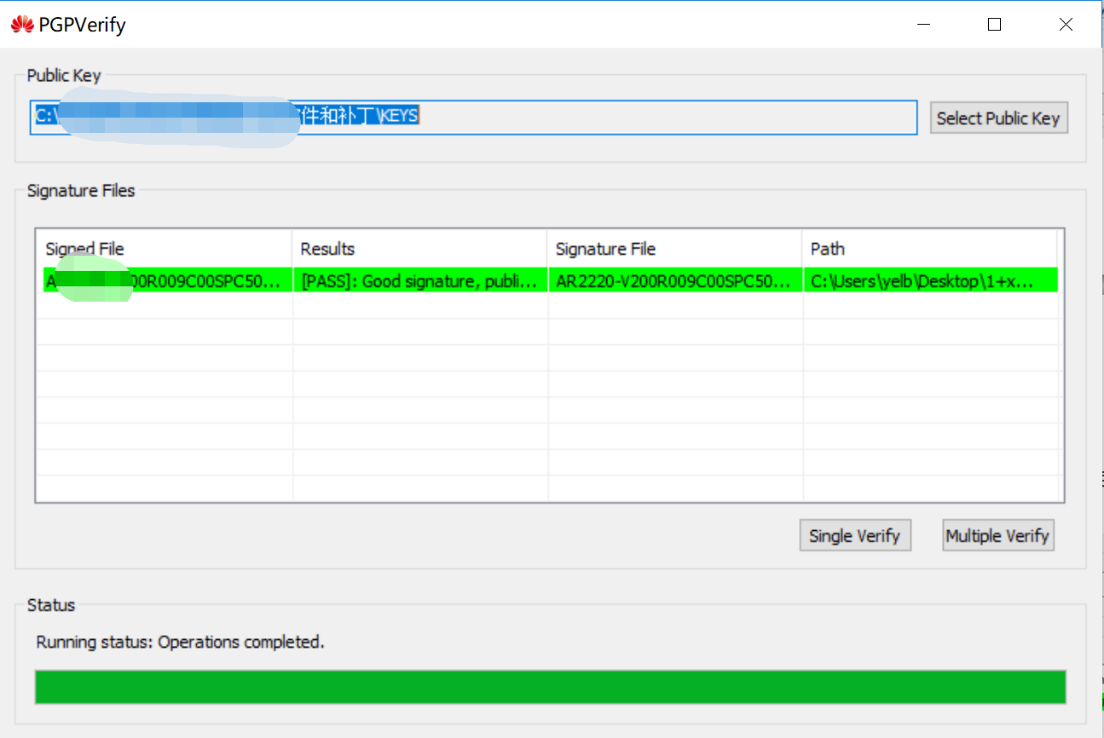

#Verify the integrity of the patch file. Click **Single Verify** and select the digital signature file for the patch file.

Verifying the integrity of the patch file

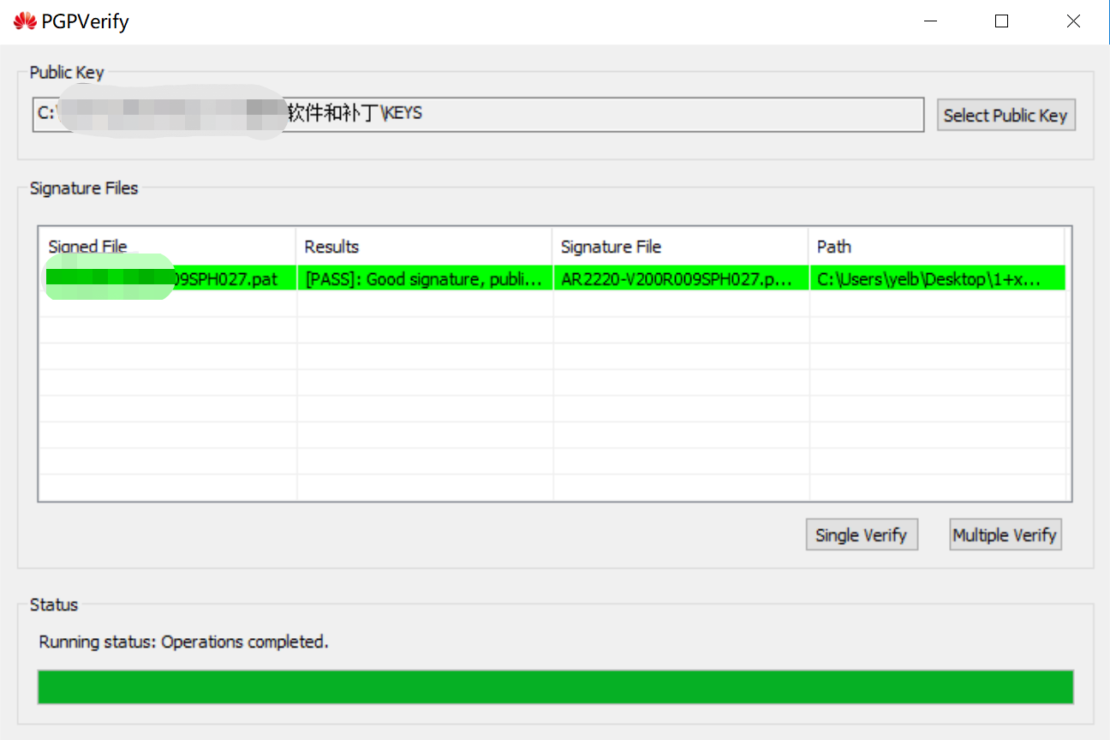

Check whether the current device meets the pre-upgrade requirements.

#Check the current system software version. Run the **display version** command in the user view to check the version of the system software running on the device. Compare the current system software version with the target one to determine whether the current system software needs to be upgraded.

<R1>display version

Huawei Versatile Routing Platform Software

VRP (R) software, Version 5.120 (AR2200 V200R003C01SPC900)

Copyright (C) 2011-2013 HUAWEI TECH CO., LTD

Huawei AR2220 Router uptime is 0 week, 0 day, 2 hours, 4 minutes

BKP 0 version information:

1. PCB Version : AR01BAK2A VER.A

2. If Supporting PoE : No

3. Board Type : AR2220

4. MPU Slot Quantity : 1

5. LPU Slot Quantity : 6

MPU 0(Master) : uptime is 0 week, 0 day, 2 hours, 4 minutes

SDRAM Memory Size : 2048 M bytes

Flash Memory Size : 16 M bytes

NVRAM Memory Size : 512 K bytes

SD Card1 Memory Size : 1914 M bytes

MPU version information :

1. PCB Version : AR01SRU2A VER.B

2. MAB Version : 0

3. Board Type : AR2220

4. CPLD0 Version : 104

5. BootROM Version : 654

LPU 1 : uptime is 0 week, 0 day, 2 hours, 4 minutes

SDRAM Memory Size : 96 K bytes

Flash Memory Size : 384 K bytes

LPU version information :

1. PCB Version : AR01SEG1CA VER.B

2. MAB Version : 0

3. Board Type : 2FE

4. BootROM Version : cb

LPU 2 : uptime is 0 week, 0 day, 2 hours, 4 minutes

SDRAM Memory Size : 96 K bytes

Flash Memory Size : 384 K bytes

LPU version information :

1. PCB Version : AR01SEG1CA VER.B

2. MAB Version : 0

3. Board Type : 2FE

4. BootROM Version : cb

LPU 3 : uptime is 0 week, 0 day, 2 hours, 3 minutes

SDRAM Memory Size : 256 M bytes

Flash Memory Size : 16 M bytes

LPU version information :

1. PCB Version : AR01SDSA2A VER.C

2. MAB Version : 0

3. Board Type : 2SA

4. BootROM Version : 305

LPU 4 : uptime is 0 week, 0 day, 2 hours, 3 minutes

SDRAM Memory Size : 256 M bytes

Flash Memory Size : 16 M bytes

LPU version information :

1. PCB Version : AR01SDSA2A VER.C

2. MAB Version : 0

3. Board Type : 1SA

4. BootROM Version : 305

#Check current system file information. Run the **display startup** command in the user view to check the system files in use. Record the file names for file backup.

<R1>display startup

MainBoard:

Startup system software: sd1:/ar2220-v200r003c01spc900.cc

Next startup system software: sd1:/ar2220-v200r003c01spc900.cc

Backup system software for next startup: null

Startup saved-configuration file: sd1:/vrpcfg.zip

Next startup saved-configuration file: sd1:/vrpcfg.zip

Startup license file: null

Next startup license file: null

Startup patch package: sd1:/ar2220-v200r003sph006.pat

Next startup patch package: sd1:/ar2220-v200r003sph006.pat

Startup voice-files: null

Next startup voice-files: null

#Check the device running status. Run the **display device** command in the user view to check the running status of MPUs and LPUs. Ensure that MPUs and LPUs are working properly.

<R1>display device

AR2220's Device status:

Slot Sub Type Online Power Register Alarm Primary

- - - - - - - - - - - - - - - - - - - - - - - - - - - - - - - - - - - - - - - -

1 - 2FE Present PowerOn Registered Normal NA

2 - 2FE Present PowerOn Registered Normal NA

3 - 2SA Present PowerOn Registered Normal NA

4 - 1SA Present PowerOn Registered Normal NA

0 - AR2220 Present PowerOn Registered Normal Master

7 - PWR150A Present PowerOn Registered Normal NA

#Check the available space in the flash memory or SD card. Run the **dir** command in the user view to check whether the available space in the flash memory or SD card is sufficient for the target system software.

Perform CLI-based software upgrade and patch management. In this exercise, FTP is used for file transfer, and the router functions as the FTP server.

#Enable the FTP server on the router. Set the FTP user name to **ftpuser**, password to **huawei123**, user privilege level to **level 3**, and root directory to **sd1:**.

[R1]ftp server enable

[R1]set default ftp-directory sd1:/

[R1]aaa

[R1-aaa]local-user ftpuser password cipher huawei123

[R1-aaa]local-user ftpuser service-type ftp

[R1-aaa]local-user ftpuser privilege level 15

[R1-aaa]local-user ftpuser ftp-directory sd1:

#Log in to the FTP server from the maintenance terminal where the target system software and patch are downloaded, and upload the target system software and patch file. Select the binary mode when uploading files through FTP, as shown in the following information in red.

C:\Users\administrator>ftp 192.168.11.1

Connected to 192.168.11.1

220 FTP service ready.

530 Please login with USER and PASS.

User (192.168.11.1:(none)): ftpuser

331 Password required for ftpuser.

Password:

230 User logged in.

ftp> binary

ftp> put AR2220-V200R009C00SPC500.zip

200 Port command okay.

150 Opening BINARY mode data connection for AR2220-V200R009C00SPC500.zip.

226 Transfer complete.

ftp: 157082321 byte(s) sent in 468.11 second(s) 335.56 Kbyte(s)/sec.

ftp> put AR2220-V200R009SPH027.pat

200 Port command okay.

150 Opening ASCII mode data connection for AR2220-V200R009SPH027.pat.

226 Transfer complete.

ftp: 7438976 byte(s) sent in 22.72 second(s) 327.42 Kbyte(s)/sec.

#After the upload is complete, run the **dir** command on R1 to check whether the file transfer is complete.

<R1>dir

Directory of sd1:/

Idx Attr Size(Byte) Date Time(LMT) FileName

0 -rw- 94,689,536 Aug 23 2013 03:38:36 ar2220-v200r003c01spc900.cc

1 -rw- 286,620 Dec 29 2013 13:24:52 sacrule.dat

2 -rw- 512,000 May 08 2020 14:44:20 mon\_file.txt

3 -rw- 478,848 Dec 29 2013 09:14:20 ar2220-v200r003sph006.pat

4 drw- - Oct 17 2017 09:01:22 logfile

5 -rw- 943 May 08 2020 15:02:58 vrpcfg.zip

6 -rw- 415 May 08 2020 15:02:58 private-data.txt

7 -rw- 247,936 Oct 16 2019 12:19:30 mon\_lpu\_file.txt

8 -rw- 889 May 13 2019 17:07:32 vrpcfg\_old.zip

9 -rw- 7,438,976 May 08 2020 16:41:46 ar2220-v200r009sph027.pat

10 -rw- 157,082,321 May 08 2020 15:37:42 ar2220-v200r009c00spc500.zip

1,960,944 KB total (1,700,468 KB free)

#Back up important files on the device. Log in to the FTP server and run the **get** command to back up the old system software, patch, and configuration file.

#Set the system software and load the patch file.

Set the system software.

1. Decompress the system software.

<R1>unzip sd1:/ar2220-v200r009c00spc500.zip sd1:/ar2220-v200R009c00spc500.cc

1. Specify the system software for next startup.

<R1> startup system-software sd1:/ar2220-v200R009c00spc500.cc

This operation will take several minutes, please wait........

Info: Succeeded in setting the file for booting system

Load the patch file.

<R1>startup patch sd1:/ar2220-v200r009sph027.pat

This operation will take several minutes, please wait.......................................................

Info: Succeeded in setting the file for booting system

Run the **display startup** command to verify that the specified system software for next startup is the newly loaded system software.

<R1>display startup

MainBoard:

Startup system software: sd1:/ar2220-v200r003c01spc900.cc

Next startup system software: sd1:/ar2220-v200r009c00spc500.cc

Backup system software for next startup: null

Startup saved-configuration file: sd1:/vrpcfg.zip

Next startup saved-configuration file: sd1:/vrpcfg.zip

Startup license file: null

Next startup license file: null

Startup patch package: sd1:/ar2220-v200r003sph006.pat

Next startup patch package: sd1:/ar2220-v200r009sph027.pat

Startup voice-files: null

Next startup voice-files: null

Restart the device. Run the **reboot** command to restart the device. Then the device automatically starts up with the newly loaded system software and configuration file. When the system asks you whether to save the configuration, enter **y** or **n** as required. After the settings are complete, enter **y** to restart the device.

<R1>reboot

Info: The system is comparing the configuration, please wait.

Warning: All the configuration will be saved to the next startup configuration. Continue ? [y/n]:y

**//**If the old configuration file has been translated using eDesk, enter **n** after you run the **reboot** command; otherwise, the current configuration will be written into the configuration file for next startup and the translated configuration file will be invalid.

It will take several minutes to save configuration file, please wait...

Configuration file had been saved successfully

Note: The configuration file will take effect after being activated

System will reboot! Continue ? [y/n]:y

Info: system is rebooting ,please wait...

Perform web-based software upgrade and patch management.

#Set up a web login environment on R1.

[R1] aaa

[R1-aaa] local-user huawei password cipher huawei123

[R1-aaa] local-user huawei privilege level 3

[R1-aaa] local-user huawei service-type http

[R1] http secure-server enable

[R1] http server enable

[R1] http secure-port 8443

[R1]http server port 8080

[R1]http server permit interface GigabitEthernet0/0/0

[R1]http timeout 15

#Log in to the web system from a maintenance terminal where the target system software and patch are loaded.

#Load the system software.

Loading system software

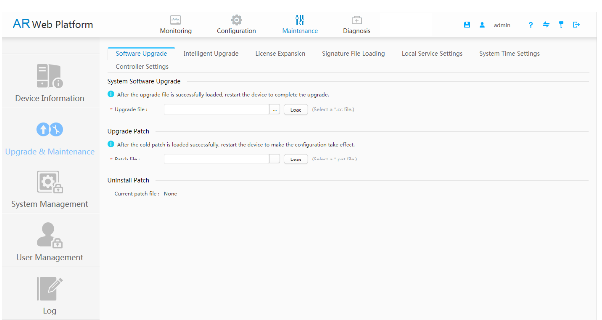

1. Choose **Maintenance** > **Upgrade &** **Maintenance** > **System Software Upgrade**.
2. Click **Browse**, and select the system software to be uploaded.
3. Click **Load** to upload the system software to the device and specify the system software for next startup.
4. Restart the device for the system software to take effect.

#Load the patch file in the same way.

1. Choose **Maintenance** > **Upgrade & Maintenance** > **Upgrade Patch**.
2. Click **Browse**, and select the patch file to be uploaded.
3. Click **Load**.
4. Restart the device for the patch file to take effect.

#(Optional) Load the configuration file in the same way.

1. Choose **Maintenance** > **Upgrade & Maintenance** > **Configuration File Management**.
2. Click **Browse**, and select the configuration file to be uploaded.
3. Click **Load**. Upload the configuration file to the device and specify the file as the configuration file for next startup.
4. Restart the device for the configuration file to take effect.
5. Choose **Maintenance** > **Configuration File Management**, and click **Restore Factory Settings**.
6. Click **Save** to save the factory settings.

----End

* 1. **Verification**

#Check whether the system software version and patch version have been updated.

<R1>display version

Huawei Versatile Routing Platform Software

VRP (R) software, Version 5.170 (AR2200 V200R009C00SPC500)

Copyright (C) 2011-2018 HUAWEI TECH CO., LTD

Huawei AR2220 Router uptime is 0 week, 0 day, 0 hour, 4 minutes

BKP 0 version information:

1. PCB Version : AR01BAK2A VER.A

2. If Supporting PoE : No

3. Board Type : AR2220

4. MPU Slot Quantity : 1

5. LPU Slot Quantity : 6

MPU 0(Master) : uptime is 0 week, 0 day, 0 hour, 2 minutes

SDRAM Memory Size : 2048 M bytes

Flash 0 Memory Size : 16 M bytes

NVRAM Memory Size : 512 K bytes

SD Card1 Memory Size : 1915 M bytes

MPU version information :

1. PCB Version : AR01SRU2A VER.B

2. MAB Version : 0

3. Board Type : AR2220

4. CPLD0 Version : 104

5. BootROM Version : 963

LPU 4 : uptime is 0 week, 0 day, 0 hour, 0 minute

SDRAM Memory Size : 256 M bytes

Flash 0 Memory Size : 16 M bytes

LPU version information :

1. PCB Version : AR01SDSA2A VER.C

2. MAB Version : 0

3. Board Type : 1SA

4. BootROM Version : 510

<R1>display startup

MainBoard:

Startup system software: sd1:/ar2220-v200r009c00spc500.cc

Next startup system software: sd1:/ar2220-v200r009c00spc500.cc

Backup system software for next startup: null

Startup saved-configuration file: sd1:/vrpcfg.zip

Next startup saved-configuration file: sd1:/vrpcfg.zip

Startup license file: null

Next startup license file: null

Startup patch package: sd1:/ar2220-v200r009sph027.pat

Next startup patch package: sd1:/ar2220-v200r009sph027.pat

Startup voice-files: null

Next startup voice-files: null

#Check whether the device status is normal.

<R1>display device

AR2220's Device status:

Slot Sub Type Online Power Register Alarm Primary

- - - - - - - - - - - - - - - - - - - - - - - - - - - - - - - - - - - - - - - -

1 - 2FE Present PowerOn Registered Normal NA

2 - 2FE Present PowerOn Registered Normal NA

3 - 2SA Present PowerOn Registered Normal NA

4 - 1SA Present PowerOn Registered Normal NA

0 - AR2220 Present PowerOn Registered Normal Master

7 - PWR150A Present PowerOn Registered Normal NA



In O&M, you also need to check whether the device configurations and services are restored. In this exercise, you can skip this step.

#Delete unnecessary files from the flash card or SD card.

<R1>delet sd1:/AR2220-V200R003C01SPC900.cc

<R1>delet sd1:/ar2220-v200r009c00spc500.zip

<R1>delete sd1:/ar2220-v200r003sph006.pat